Project Design Phase-II
Data Flow Diagram & User Stories

Date | 31 January 2025
Team ID
Project Name | ShopEZ
Maximum Marks | 4 Marks

Data Flow Diagrams:
A Data Flow Diagram (DFD) is a traditional visual representation of the information flows within a system. A neat and clear DFD can depict the right amount of the system requirement graphically. It shows how data enters and leaves the system, what changes the information, and where data is stored.
Example: DFD Level 0 (Industry Standard)
Example: (Simplified)
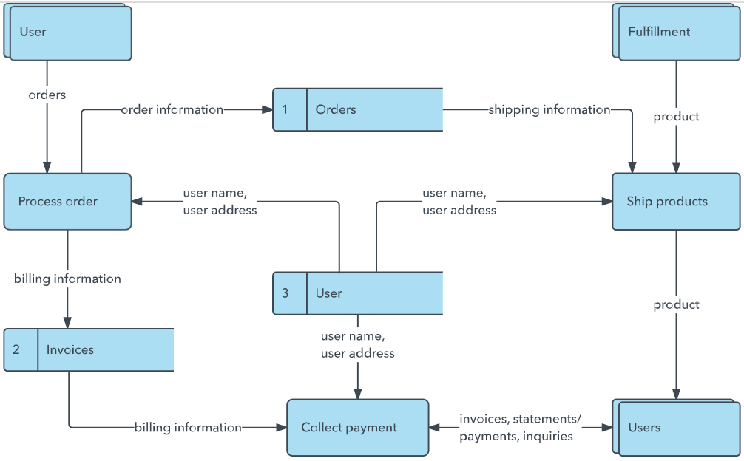

DFD Level 0 (Context Diagram)
External Entities: Customer, Administrator
Main Process: ShopEZ E-Commerce System
Data Flows: Registration/Login Data, Product Requests, Cart Data, Orders, Reviews, Admin Management Requests, Reports and Responses.
DFD Level 1
Processes:
1. User Authentication
2. Product Management
3. Cart Management
4. Order Processing
5. Review Management
6. Admin Dashboard Operations
Data Stores:
User Database, Product Database, Cart Database, Order Database, Admin Database

User Stories
User Type | Epic | User Story Number | User Story / Task | Acceptance Criteria | Priority | Release
Customer | Registration | USN-1 | Register using email and password | Account created successfully | High | Sprint-1
Customer | Login | USN-2 | Login using credentials | Dashboard accessible | High | Sprint-1
Customer | Products | USN-3 | Browse products | Products displayed correctly | High | Sprint-2
Customer | Search | USN-4 | Search and filter products | Relevant products shown | High | Sprint-2
Customer | Reviews | USN-5 | Submit product review | Review saved successfully | Medium | Sprint-2
Customer | Cart | USN-6 | Add products to cart | Cart updated | High | Sprint-3
Customer | Checkout | USN-7 | Place an order | Order generated successfully | High | Sprint-3
Customer | Orders | USN-8 | Track order status | Status visible | High | Sprint-3
Customer | Orders | USN-9 | Cancel order | Order marked cancelled | Medium | Sprint-3
Administrator | Admin Login | USN-10 | Login to admin dashboard | Dashboard accessible | High | Sprint-4
Administrator | Products | USN-11 | Add/Edit/Delete products | Product database updated | High | Sprint-4
Administrator | Orders | USN-12 | Manage order status | Status updated successfully | High | Sprint-4
Administrator | Users | USN-13 | View all users | User data displayed | Medium | Sprint-4
Administrator | Banners | USN-14 | Manage promotional banners | Banner changes reflected | Medium | Sprint-4

